**02 - Finding Time Complexity of**

**Algorithms**

|  |  |
| --- | --- |
| **Ex. No. : 2.1** | **Date: 20.08.24** |
| **Register No.: 230701358** | **Name: TARUN C** |



AIM:

**Convert the following algorithm into a program and find its time complexity using the counter method.**

**void function (int n)**

**{**

**int i= 1;**

**int s =1;**

**while(s <= n)**

**{ i++;**

**s += i;**

**}**

**}**

**Note: No need of counter increment for declarations and scanf() and count variable printf() statements.**

**Input:**

**A positive Integer n Output:**

**Print the value of the counter variable**

**For example:**

|  |  |
| --- | --- |
| Input | RESULT |
| 9 | 12 |

ALGORITHM:

Step 1: Start

Step 2: Read the value of n from the user.

Step 3: Call the function func(n), initializing count, i to 1, and s to

1. Increment count (1st increment).

Step 4: While s <= n, increment count (2nd increment), then increment i and update s by adding i. Increment count again (3rd increment).

Step 5: After exiting the loop, increment count (4th increment).

Step 6: Print the value of count.

Step 7: End

PROGRAM:

#include<stdio.h> void function(int n)

{

int count=0; int i=1; count++; int s=1; count++; while(s<=n) {

i++; count++; s+=i; count++; count++;

}

count++; printf("%d",count);

}

int main()

{

int n; scanf("%d",&n); function(n);

}

OUTPUT:

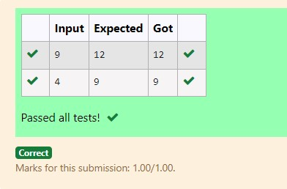

RESULT:

Hence the above program has been executed successfully.

|  |  |
| --- | --- |
| **Ex. No. : 2.2** | **Date: 20.08.24** |
| **Register No.: 230701358** | **Name: TARUN C** |



AIM:

**Convert the following algorithm into a program and find its time complexity using the counter method.**

**void func(int n){ if(n==1){ printf("*");} else{ for(int i=1; i<=n; i++){ for(int j=1; j<=n; j++){ printf("*"); printf("*"); break;**

**}}}}**

**Note: No need of counter increment for declarations and scanf() and count variable printf() statements.**

**Input:**

**A positive Integer n**

**Output:**

**Print the value of the counter variable**

ALGORITHM:

Step 1: Start

Step 2: Read the value of n from the user.

Step 3: Call the function func(n).

Step 4: In func, if n == 1, increment count (1st increment).

Step 5: If n > 1, increment count (2nd increment) and loop i from 1 to n, increment count (3rd increment) for each iteration, and loop j from 1 to n, incrementing count (4th increment) three times, then break. Increment count (5th increment) after the inner loop, and once more after the outer loop (6th increment).

Step 6: Print the value of count.

Step 7: End

PROGRAM:

#include<stdio.h> void func(int n)

{

int count=0; if(n==1)

{

count++;

}

else

{

count++; for(int i=1;i<=n;i++)

{

count++; for(int j=1;j<=n;j++)

{

count++; count++; count++; break;

}

count++;

}

count++;

}

printf("%d",count);

}

int main()

{

int n; scanf("%d",&n); func(n);

}

OUTPUT:

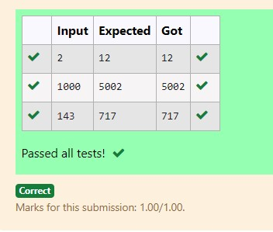

RESULT:

Hence the above program has been executed successfully.

|  |  |
| --- | --- |
| **Ex. No. : 2.3** | **Date: 20.08.24** |
| **Register No.: 230701358** | **Name: TARUN C** |



AIM:

**Convert the following algorithm into a program and find its time complexity using counter method.**

**Factor(num) {**

**{**

**for (i = 1; i <= num;++i)**

**{**

**if (num % i== 0)**

**{ printf("%d ", i);**

**}**

**} }**

**Note: No need of counter increment for declarations and scanf() and counter variable printf() statement.**

**Input:**

**A positive Integer n Output:**

**Print the value of the counter variable**

ALGORITHM:

Step 1: Start

Step 2: Read the value of n from the user.

Step 3: Call the function Factor(n).

Step 4: In Factor, loop i from 1 to num, increment count (1st increment).

Step 5: For each i, check if num % i == 0. If true, increment count (2nd increment). Increment count again (3rd increment) for the end of the loop.

Step 6: After the loop, increment count (4th increment).

Step 7: Print the value of count.

Step 8: End

PROGRAM:

#include<stdio.h> void Factor(int num)

{

int i,count=0; for(i=1;i<=num;i++)

{

count++; if(num%i==0)

{

count++;

}

count++;

}

count++; printf("%d",count);

}

int main()

{

int num; scanf("%d",&num);

Factor(num);

}

OUTPUT:

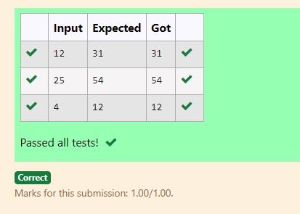

RESULT:

Hence the above program has been executed successfully.

|  |  |
| --- | --- |
| **Ex. No. : 2.4** | **Date: 20.08.24** |
| **Register No.: 230701358** | **Name: TARUN C** |



AIM:

**Convert the following algorithm into a program and find its time complexity using counter method.**

**void function(int n)**

**{**

**int c= 0; for(int i=n/2; i<n; i++) for(int j=1; j<n; j = 2 * j) for(int k=1; k<n; k = k * 2)**

**c++;**

**}**

**Note: No need of counter increment for declarations and scanf() and count variable printf() statements.**

**Input:**

**A positive Integer n**

**Output:**

**Print the value of the counter variable**

ALGORITHM:

Step 1: Start

Step 2: Read the value of n from the user.

Step 3: Call the function function(n).

Step 4: In function, initialize c to 0 and increment count (1st increment).

Step 5: Loop i from n/2 to n, incrementing count (2nd increment), and for each i, loop j from 1 to n, doubling j each time, incrementing count (3rd increment).

Step 6: Inside the j loop, loop k from 1 to n, doubling k each time, incrementing count (4th increment), increment c, and increment count (5th increment). Increment count again after the k loop (6th increment) and after the j loop (7th increment).

Step 7: Increment count after the i loop (8th increment).

Step 8: Print the value of count.

Step 9: End

PROGRAM:

#include<stdio.h> void function(int n)

{

int count=0; int c=0; count++; for(int i=n/2;i<n;i++)

{

count++; for(int j=1;j<n;j=2*j)

{

count++; for(int k=1;k<n;k=k*2)

{

c++; count++; count++;

}

count++;

}

count++;

}

count++; printf("%d",count);

}

int main()

{

int n; scanf("%d",&n); function(n);

}

OUTPUT:

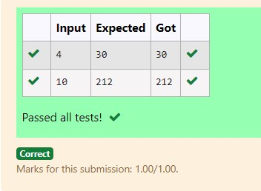

RESULT:

Hence the above program has been executed successfully.

|  |  |
| --- | --- |
| **Ex. No. : 2.5** | **Date: 20.08.24** |
| **Register No.: 230701358** | **Name: TARUN C** |



AIM:

**Convert the following algorithm into a program and find its time complexity using counter method. void reverse(int n)**

**{ int rev = 0, remainder; while (n != 0)**

**{**

**remainder = n % 10; rev = rev * 10 + remainder; n/= 10;**

**} print(rev); }**

**Note: No need of counter increment for declarations and scanf() and count variable printf() statements.**

**Input:**

**A positive Integer n**

**Output:**

**Print the value of the counter variable**

ALGORITHM:

Step 1: Start

Step 2: Read the value of n from the user.

Step 3: Call the function reverse(n).

Step 4: In reverse, initialize rev to 0 and increment count (1st increment).

Step 5: While n is not 0, increment count (2nd increment), calculate remainder as n % 10, and increment count (3rd increment). Update rev by multiplying it by 10 and adding remainder, then increment count (4th increment). Divide n by 10 and increment count (5th increment).

Step 6: After exiting the loop, increment count (6th increment) and again for the commented print statement (7th increment).

Step 7: Print the value of count.

Step 8: End

PROGRAM:

#include<stdio.h> void reverse(int n)

{

int count=0; int rev=0; count++;

int remainder; count++; while(n!=0)

{

count++; remainder=n%10; count++; rev=rev*10+remainder; count++; n/=10; count++; }count++; printf("%d",count);

}

int main()

{

int n; scanf("%d",&n); reverse(n);

}

OUTPUT:

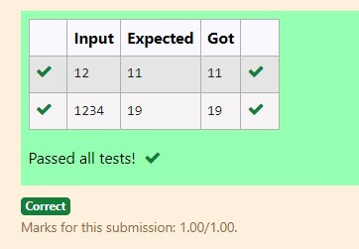

RESULT:

Hence the above program has been executed successfully.